Experiment No. 7

Aim: Implementation of different I/O operations using I/O streams

- Write a Java program that reads data from a sample.txt file located outside the program’s directory

import java.io.File;
import java.io.FileNotFoundException;
import java.util.Scanner;

public class ReadFileExample {
public static void main(String[] args) {

File file = new File("C:\\Users\\PRASANNA\\Desktop\\AOOC-Practicals-4th sem\\exp7\\sample.txt");

try {
Scanner sc = new Scanner(file);

while (sc.hasNextLine()) {
System.out.println(sc.nextLine());
}

sc.close();
} catch (FileNotFoundException e) {
System.out.println("File not found!");
}
}
}

OUTPUT :
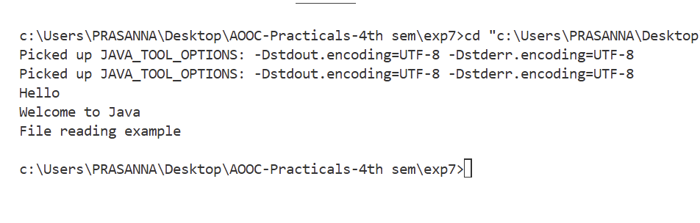

2. Develop a Java program that performs the following operations:
○ Accept student information such as name, age, weight, height, city, and phone
number from the user.
Lab Manual: AOOC
Lab manual: Advanced Object-Oriented Concepts (Java), SY CSE, Sem IV, 2025-26,
Computer Science & Engineering Dept., D.Y. Patil College of Engineering & Technology, Kasaba Bawada, Kolhapur
Page 80 of 145
○ Store this information in a file using DataOutputStream along with
FileOutputStream.
○ Retrieve and display the data using DataInputStream along with
FileInputStream

import java.io.File;
import java.io.FileNotFoundException;
import java.util.Scanner;

public class ReadFileExample {
public static void main(String[] args) {

File file = new File("C:\\Users\\PRASANNA\\Desktop\\AOOC-Practicals-4th sem\\exp7\\sample.txt");

try {
Scanner sc = new Scanner(file);

while (sc.hasNextLine()) {
System.out.println(sc.nextLine());
}

sc.close();
} catch (FileNotFoundException e) {
System.out.println("File not found!");
}
}
}

OUTPUT :

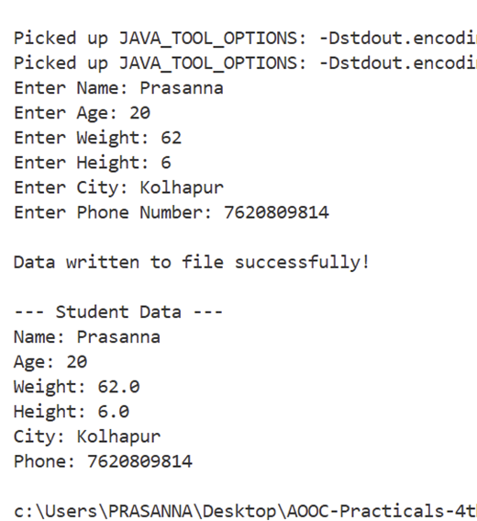

3. Write a Java program to read a text file and compute the following:
○ The total number of vowels in the file.
○ The total number of words in the file.
○ The number of times the character 'a' appears in the file

import java.io.*;
import java.util.*;

public class FileAnalysis {
public static void main(String[] args) {

int vowelCount = 0;
int wordCount = 0;
int aCount = 0;

try {
File file = new File("sample2.txt"); // change path if needed
Scanner sc = new Scanner(file);

while (sc.hasNextLine()) {
String line = sc.nextLine();

// Count words
String[] words = line.trim().split("\\s+");
if (!line.trim().isEmpty()) {
wordCount += words.length;
}

// Convert line to lowercase for easy checking
line = line.toLowerCase();

for (int i = 0; i < line.length(); i++) {
char ch = line.charAt(i);

// Count vowels
if (ch == 'a' || ch == 'e' || ch == 'i' || ch == 'o' || ch == 'u') {
vowelCount++;
}

// Count 'a'
if (ch == 'a') {
aCount++;
}
}
}

sc.close();

// Display results
System.out.println("Total vowels: " + vowelCount);
System.out.println("Total words: " + wordCount);
System.out.println("Occurrences of 'a': " + aCount);

} catch (FileNotFoundException e) {
System.out.println("File not found!");
}
}
}

OUTPUT :

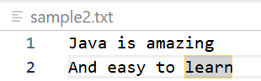
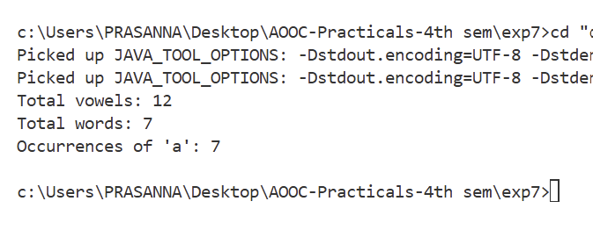

4. Write a program that takes a file name as input through the command line.
● If the file exists, open it and display its contents.
● After displaying the contents, ask the user: “Do you want to add data to the end of
the file?”
● If the user's response is "Yes", accept data from the user and append it to the file.
● If the file does not exist, create a new file and allow the user to input data to store
in it.
● The user should type “exit” on a new line to stop entering data. Implement this
program using character stream classes

import java.io.*;
import java.util.Scanner;

public class FileHandler {
public static void main(String[] args) {

// Check command-line argument
if (args.length == 0) {
System.out.println("Please provide file name as argument!");
return;
}

String fileName = args[0];
File file = new File(fileName);

Scanner sc = new Scanner(System.in);

try {
// ----------- If file exists -----------
if (file.exists()) {
System.out.println("\nFile exists. Reading content:\n");

BufferedReader br = new BufferedReader(new FileReader(file));
String line;

while ((line = br.readLine()) != null) {
System.out.println(line);
}
br.close();

// Ask user to append
System.out.print("\nDo you want to add data to the end of the file? (Yes/No): ");
String choice = sc.nextLine();

if (choice.equalsIgnoreCase("Yes")) {
BufferedWriter bw = new BufferedWriter(new FileWriter(file, true));

System.out.println("Enter data (type 'exit' to stop):");

while (true) {
String input = sc.nextLine();
if (input.equalsIgnoreCase("exit"))
break;
bw.write(input);
bw.newLine();
}

bw.close();
System.out.println("Data appended successfully!");
}

}
// ----------- If file does NOT exist -----------
else {
System.out.println("\nFile does not exist. Creating new file...");

BufferedWriter bw = new BufferedWriter(new FileWriter(file));

System.out.println("Enter data (type 'exit' to stop):");

while (true) {
String input = sc.nextLine();
if (input.equalsIgnoreCase("exit"))
break;

bw.write(input);
bw.newLine();
}

bw.close();
System.out.println("File created and data written successfully!");
}

} catch (IOException e) {
System.out.println("Error: " + e.getMessage());
}

sc.close();
}
}

OUTPUT :

